K8 Assigment2

Q1) Kubernetes Dashboard:

1. Enable kubernetes dashboard and create separate token to access it.

(Provide screenshot of it.)

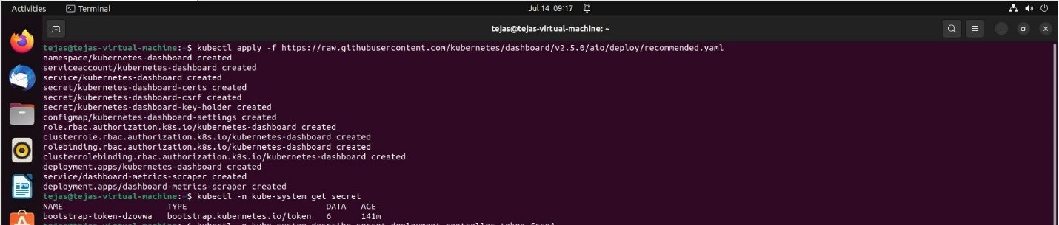

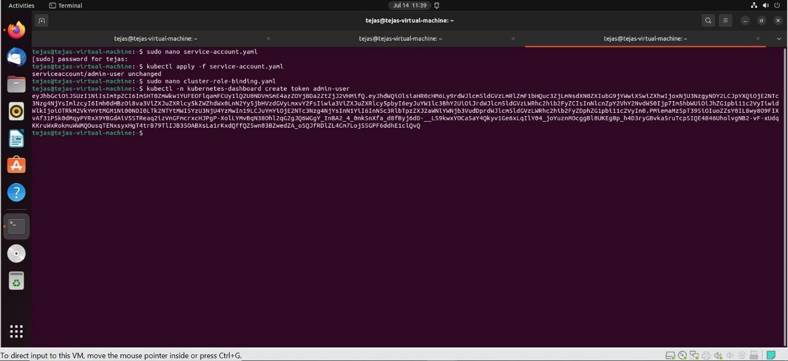

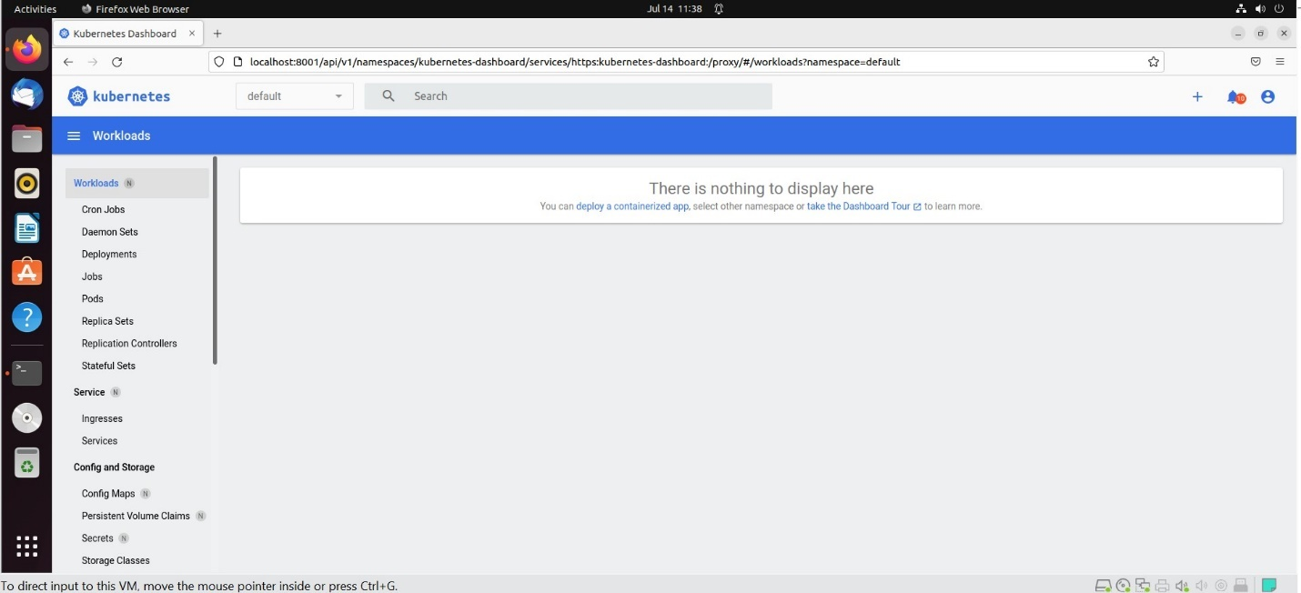

Q2) Run the helm charts helm-sample-app-0.0.1.tgz which is present inside the one-drive (mini HU K8 resources) Assignment_Resources folder.

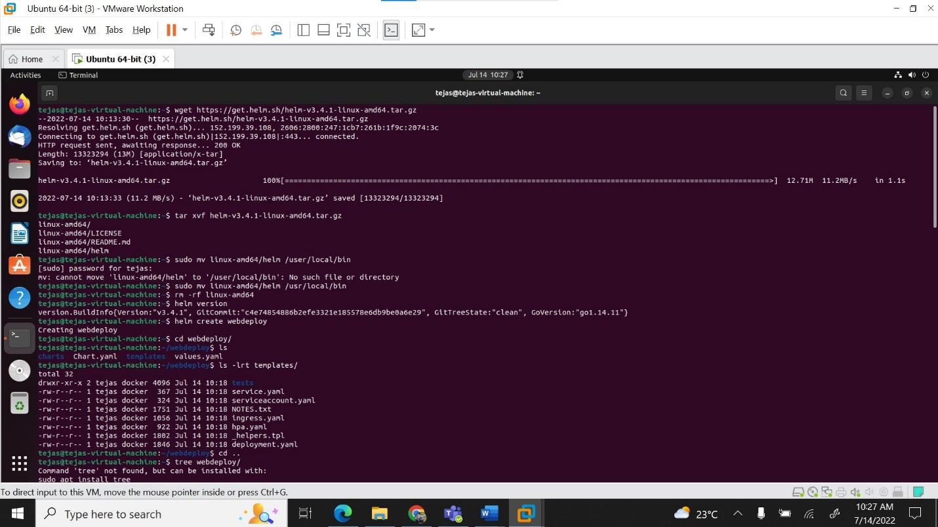

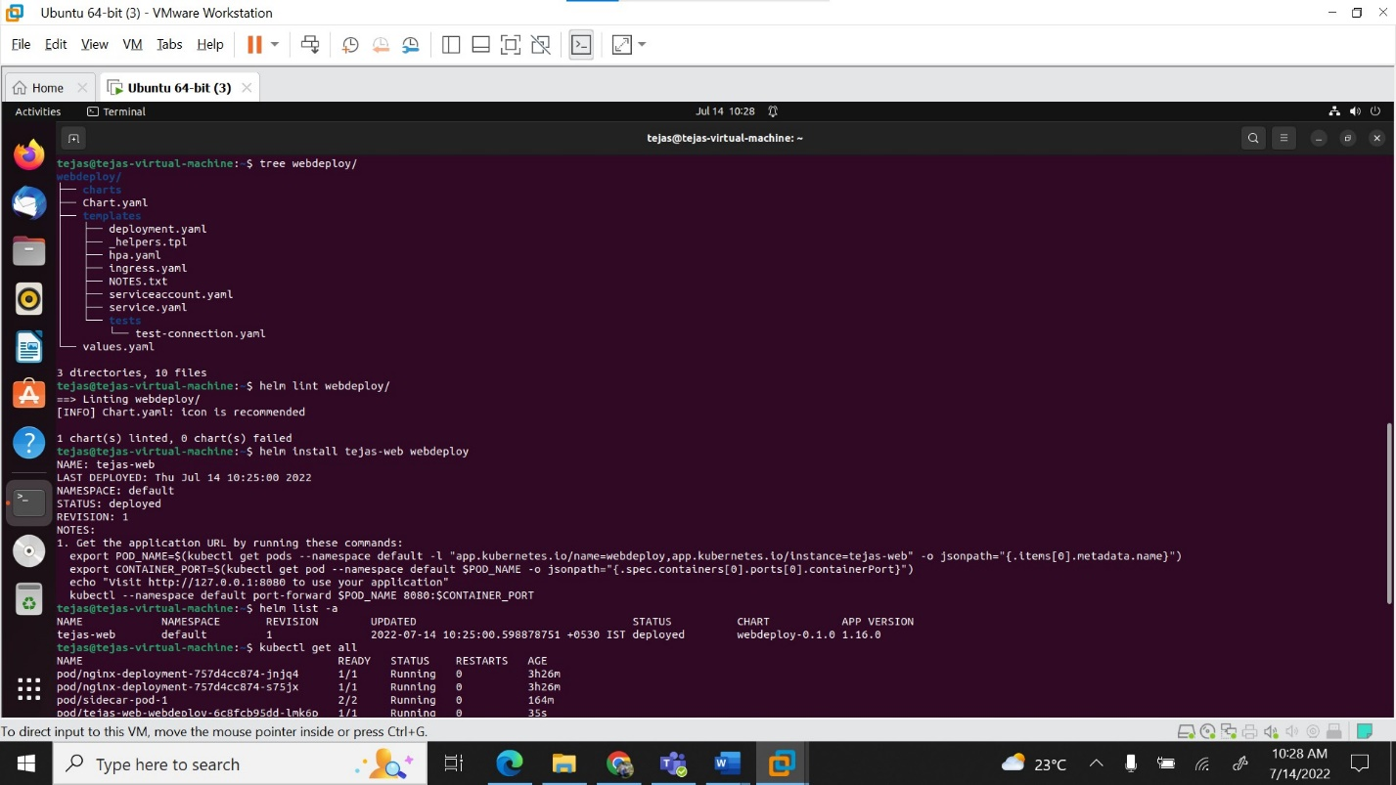

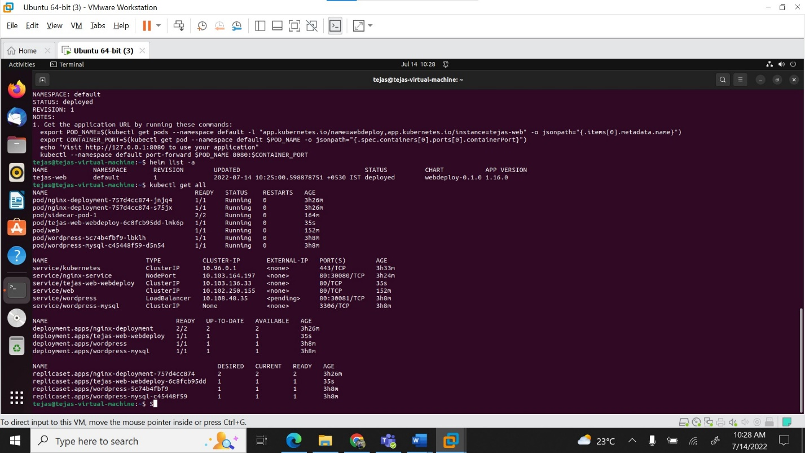

3) Update the same helm chart and upgrade the same deployment by changing the image tag to ‘1.18.0’ and replica count to 2 from 1.

Now using helm command, rollback the deployment to the previous successful deployment version.

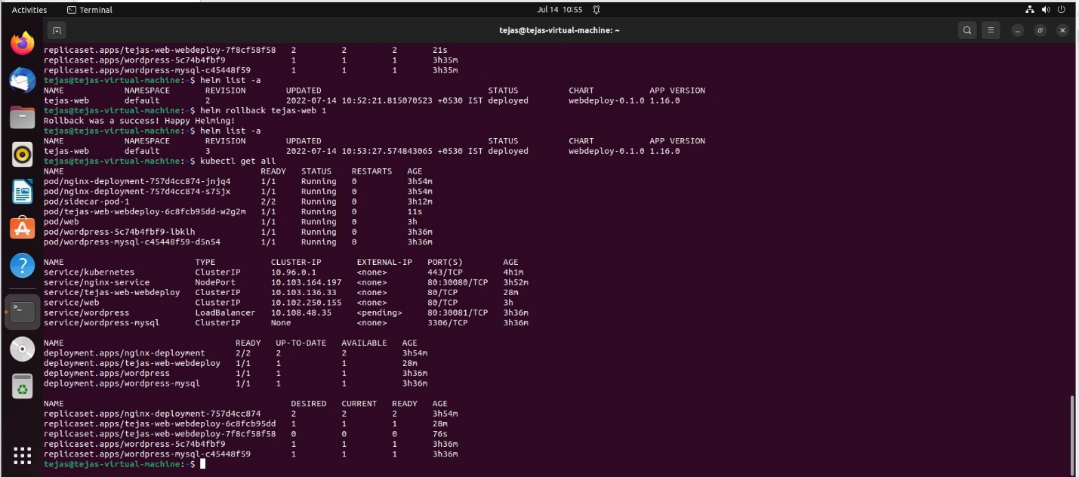

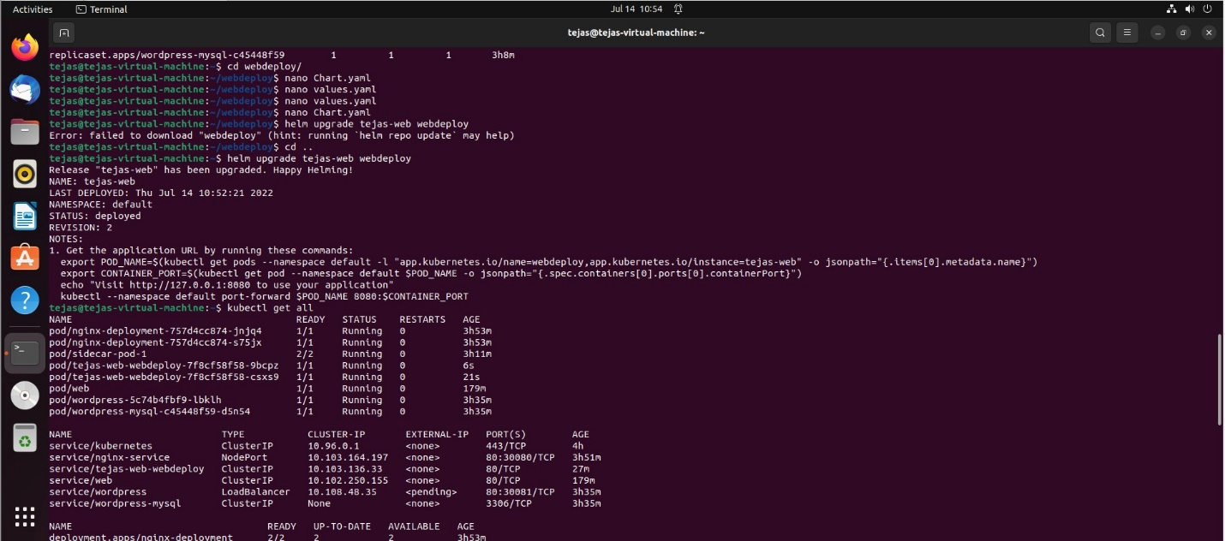

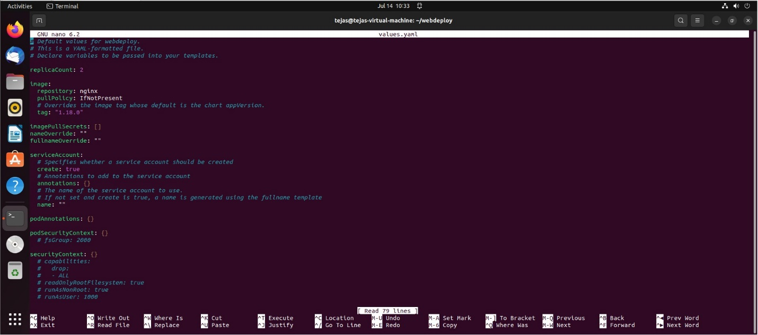

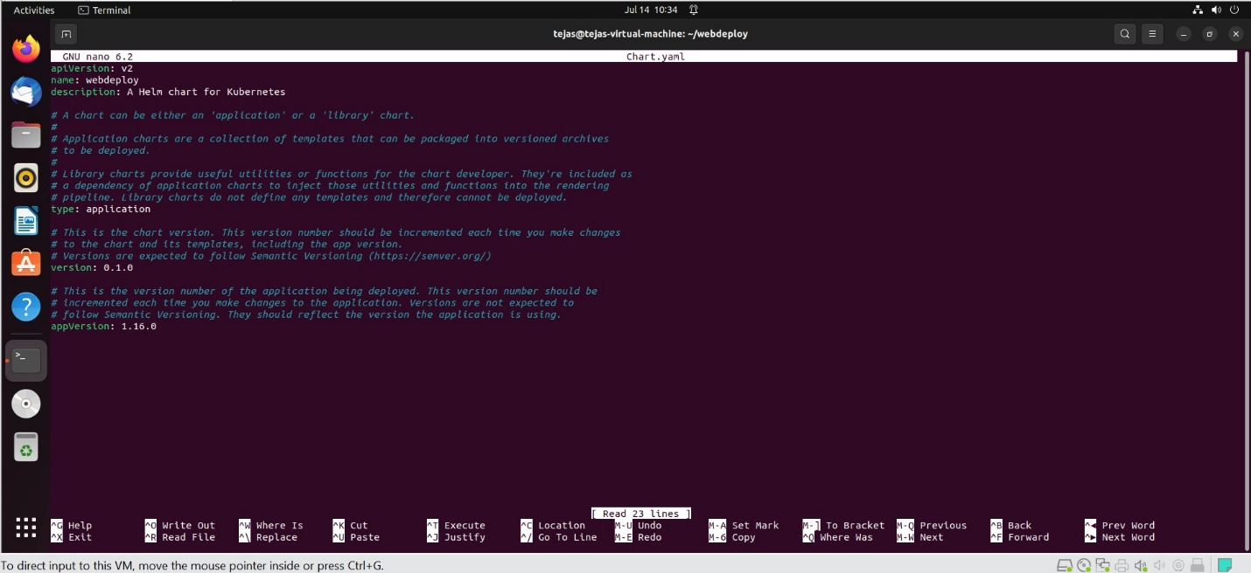

4. Run the given deployment manifest file log-deployment.yaml under the gdrive Assignment_Resources folder which has 2 containers (container1 and container2 ) placed inside the single pod.

Take the logs of both the containers one by one and write the log data over files called c1.log and c2.log

5.) Deploy metrics-server and provide the screenshot of node and pod resource usage